Task 1

That’s How the web works:

1. You type a URL into your browser.
2. The browser parses the information contained in the URL.
3. The browser communicates with your ISP to do a DNS lookup of the IP address for the web server that hosts the website.
4. When the ISP receives the IP address of the destination server, it sends it to your web browser.
5. [Your browser takes the IP address and the given port number from the URL and opens a TCP socket connection. At this point, your web browser and web server are now connected.](http://preethikasireddy.me/wp-content/uploads/2015/12/Screen-Shot-2015-12-06-at-6.32.27-PM1.png)

We will talk here about some Protocols and component related to the web:

* Client: The Client is the user of the network and he is the one who send request to the server.

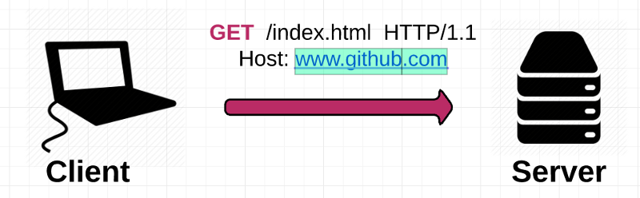

* Server: The Server is a Computer that store websites and it’s task to response to the Client requests.

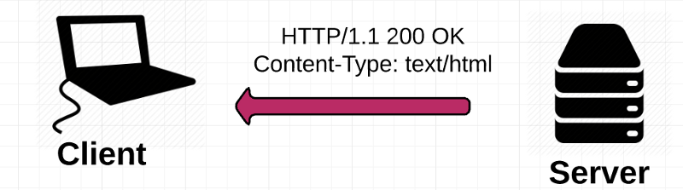

**IP address:** Internet Protocol Address. Every computer on the internet has an IP address that it uses to identify and communicate with other computers.

**ISP:** Internet Service Provider. ISP Task is to communicate between the client and servers.

**HTTP:** Hyper-text Transfer Protocol. The protocol that web browsers and web servers use to communicate with each other over the Internet.

**DNS:** Domain Name System. A distributed database which keeps track of computer’s domain names and their corresponding IP addresses on the Internet.

**TCP/IP:**  TCP/IP is used as a standard for transmitting data over networks.

